Basic requirement of this project is to analyse the nifty movement based on the various technical study like RSI, VWAP, OI analysis , price action movement etc… To get the data, we can connect to dhan websocket with proper client id and accesstoken. I have an application screen shot which is already doing these things and want exactly like so to analyse the market. I want to use react js as front end which ever is the latest version and .net core rest api . Also need a module to handle user registration and login. Also allow the user to register with their gamil id.
- Below is the home screen for the login/register to the user. Use Microsoft identity framework to control user authentication and registration. Please suggest if any other better option
  - Registration
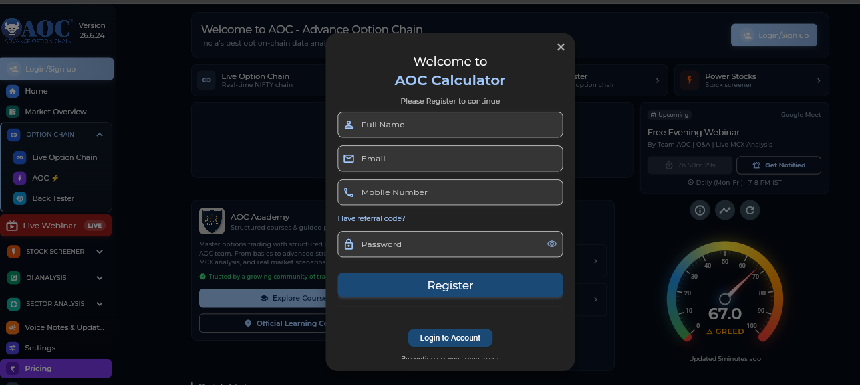

  - Login
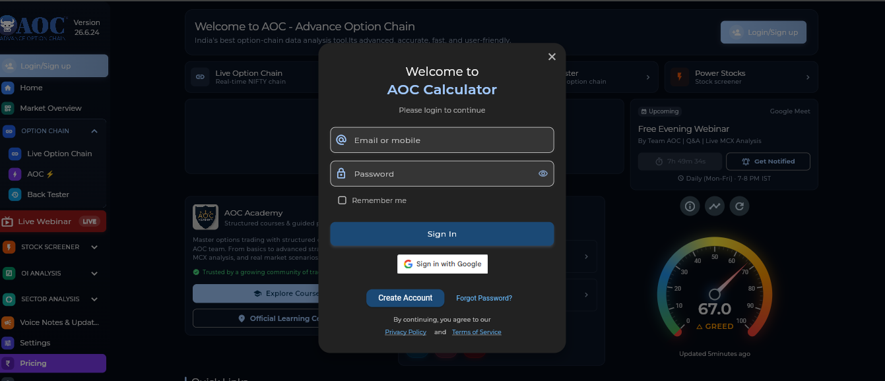

- Home page after login
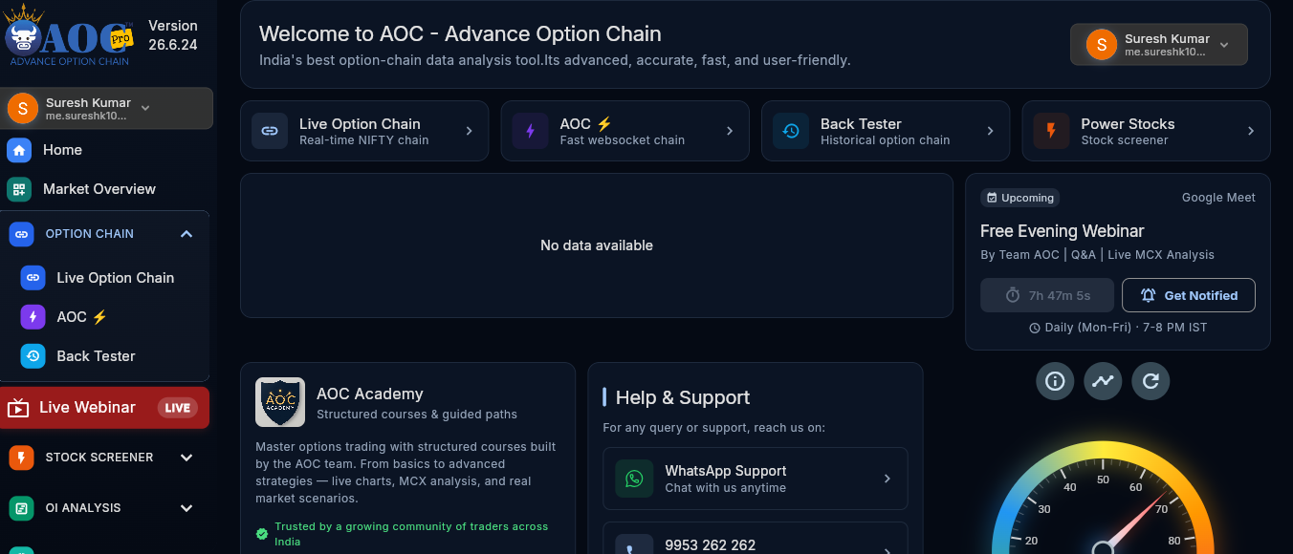

- Segment selection
When click on the live option , it will open the default nifty 50 with possible strikes . here we can limit to 10 top and bottom of current strike . for eg: 24200 here.
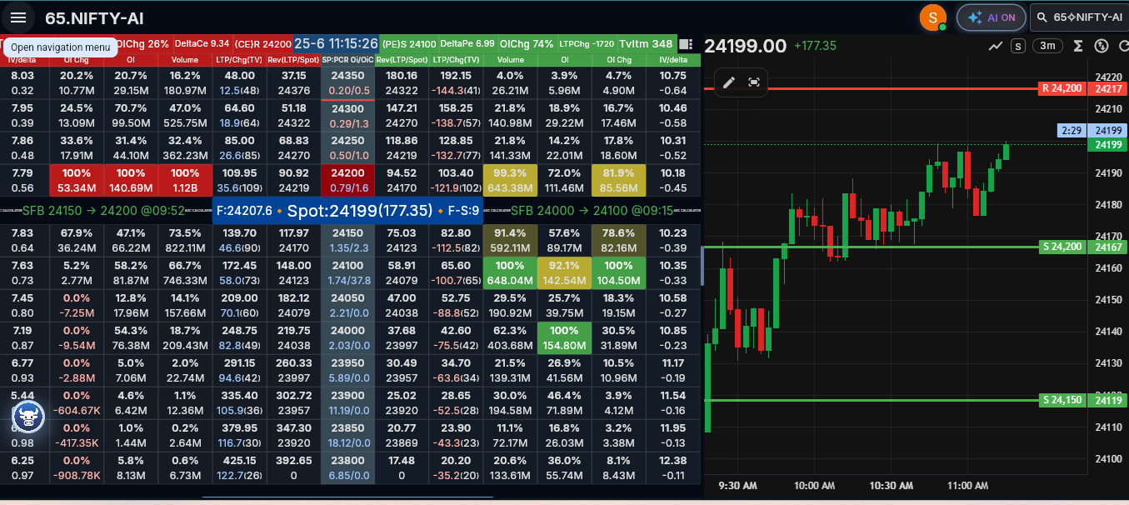
When we click on the top right NIFT-AI button , it will open all possible segements of index and stocks where user can select one at a time
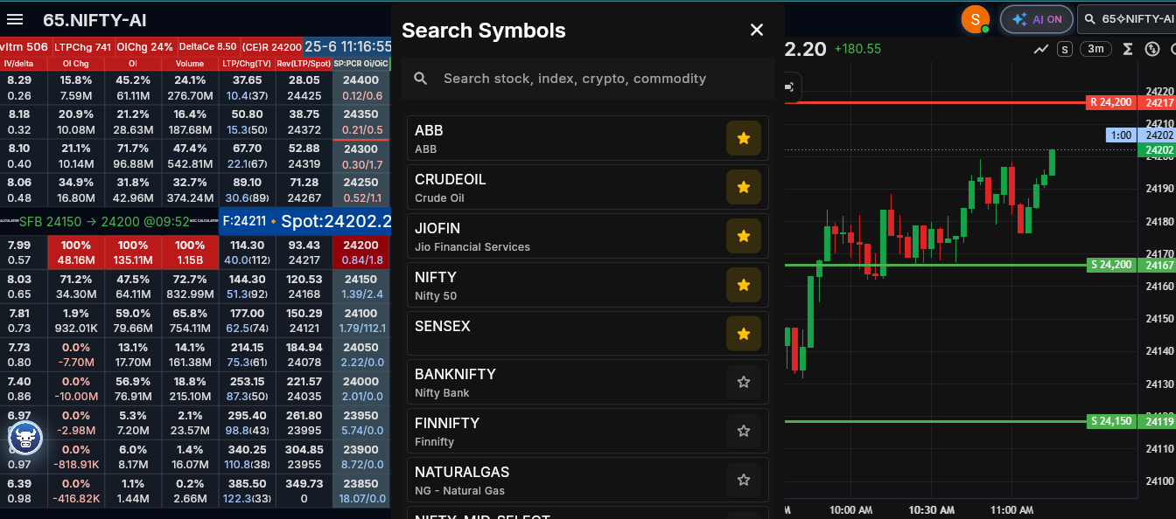
Star markings shows they are favourites and they list on top. Once selected it will open that symbol with possible option strikes. Here I selected sensex, so it shows sensex details.
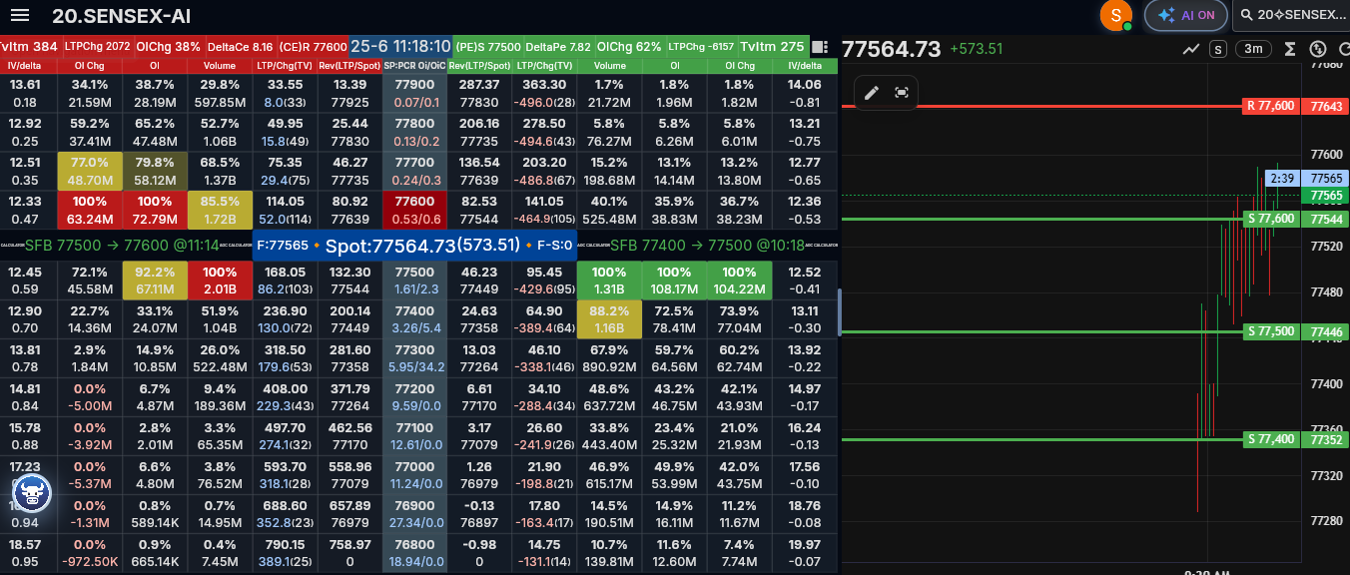
In the right panel , there is chart drawn based on the instrument selected. It will be better to in cooperate such one. The lines drawn are and Gann level for the symbol.

Also if you notice the central line , it shows the current spot and indicates CE and PE moving up or down. Also different colors indicates no of open positions where it is high. Green color in the put side shows the hight one, then orange just below and then yellow. Same follows for CE side with green as the top one.
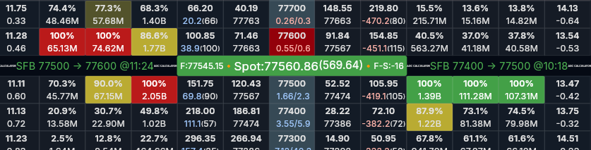

Also there are other information’s provided in the bottom. Better to include those as well.

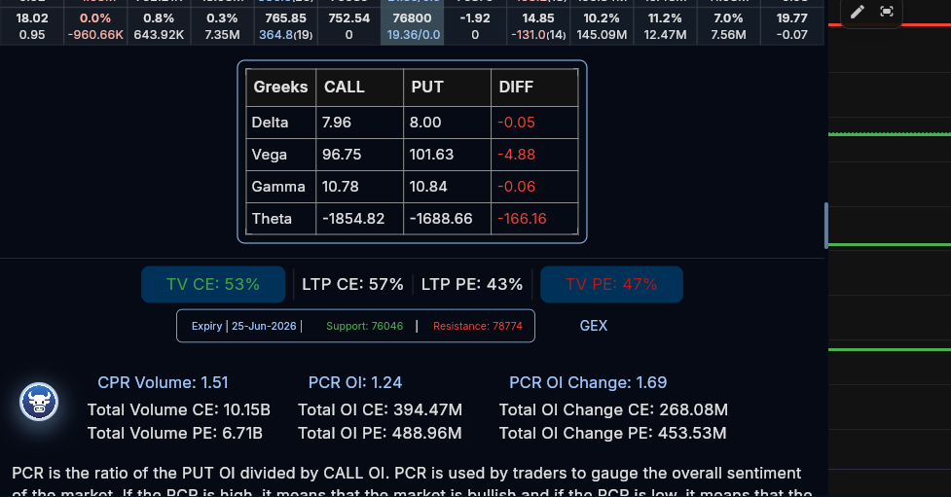

- Support and resistance of strikes
If you click on any strike, it will show the support and resistance of that strike
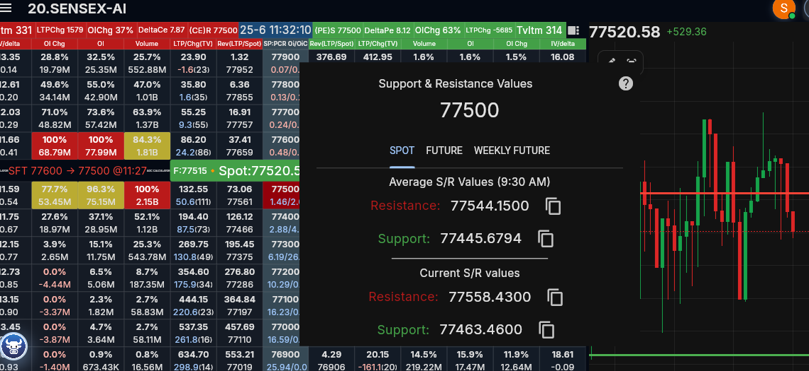

- OI charts
Below are the various charts when we clicks on each values .
IV/Delta
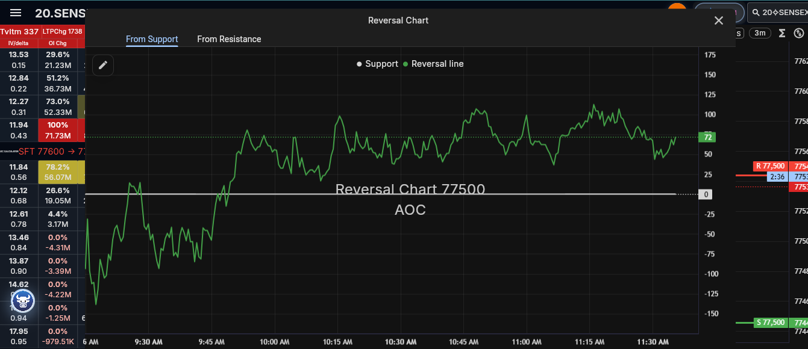

OI change
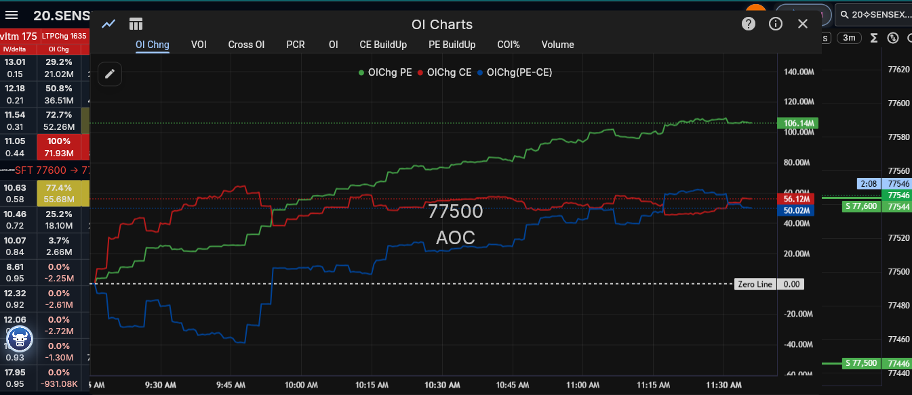

OI
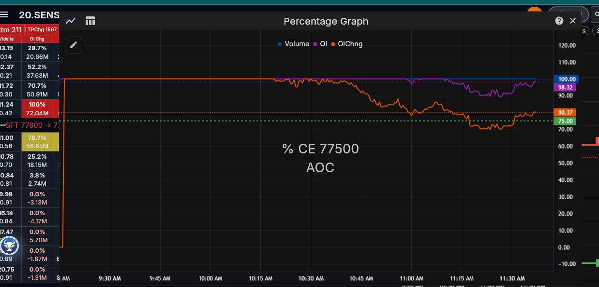

There are more such reports can make . however if found anything meaningful , please create those as well. Basically a person see this page should able to take a decision that he can buy a CE or PE , which is worthwhile.

Project Feasibility and Decision Checklist
Purpose: Use this checklist to confirm what should be included in the first project build, what can be deferred, and which third-party services or paid tools are required before development starts.
Decision options: Needed / Optional / Not Needed / Later. Fill the Decision and Notes columns before project kickoff.

Core Application Scope
Item | Suggested Need | Reason / Comment | Decision | Notes
React frontend dashboard | Needed | Required to build the screens shown in the screenshots.
.NET Core / ASP.NET Core REST API | Needed | Required backend for authentication, Dhan integration, calculations, and live updates.
Responsive desktop-first UI | Needed | The screenshots are dense trading screens; desktop should be priority. Mobile can be limited initially.
Exact UI clone of reference screenshots | Optional | Feasible, but exact clone increases effort. Recommended: same workflow and information layout, refined UI.
Admin/configuration module | Optional | Useful for managing supported symbols, expiries, and user access.

Authentication and User Management
Item | Suggested Need | Reason / Comment | Decision | Notes
User registration and login | Needed | Use ASP.NET Core Identity.
Google/Gmail login | Needed | Use Google OAuth with ASP.NET Core Identity external login.
Email confirmation and password reset | Needed | Requires email provider setup; important for production. Use .net core inbuild email services like System.Net.Mail
Roles and access control | Needed | Useful for admin/user separation and future subscription control.
Paid identity provider such as Auth0/Okta | Not Needed | ASP.NET Core Identity is enough unless enterprise SSO is required.

Market Data and Broker Integration
Item | Suggested Need | Reason / Comment | Decision | Notes
Dhan client id and access token | Needed | Required for DhanHQ REST APIs and WebSocket market feed.
Dhan live WebSocket feed | Needed | Required for live LTP, OI movement, and dashboard updates.
Dhan option-chain API | Needed | Provides strikes, OI, Greeks, IV, volume, bid/ask, and last price.
Dhan historical data API | Recommended | Needed for charts, previous movement comparison, and backtesting.
Alternative paid market data vendor | Not Needed | Only needed if Dhan limits, latency, or licensing do not satisfy requirements.
Direct browser connection to Dhan | Not Needed | Backend should connect to Dhan and stream normalized data to frontend.

Analytics and Trading Signals
Item | Suggested Need | Reason / Comment | Decision | Notes
RSI, VWAP, price action calculations | Needed | Can be calculated in backend from live/historical data.
OI analysis and OI change heatmap | Needed | Central feature from the screenshots.
PCR, volume PCR, OI PCR | Needed | Shown in bottom analytics and useful for sentiment.
IV, Delta, Gamma, Theta display | Needed | Available from option-chain data and shown in screenshots.
Support and resistance per strike | Needed | Shown as a strike-click feature.
Gann levels | Optional | Can be implemented if the exact formula/rules are confirmed.
Buy CE / Buy PE recommendation engine | Later | Should be built after rules, validation, and backtesting are defined.
Backtesting module | Recommended | Important before trusting any signal or recommendation.
AI/LLM-based recommendations | Later | Not required for MVP; paid if using OpenAI/Azure OpenAI/etc.

Charts and UI Components
Item | Suggested Need | Reason / Comment | Decision | Notes
Candlestick/line chart panel | Needed | Can use open-source charting such as TradingView Lightweight Charts.
OI charts: OI change, volume, PCR, buildup | Needed | Shown in screenshots; can be custom chart series.
TradingView Lightweight Charts | Recommended | Free/open-source charting library suitable for this use case.
Paid TradingView charting library/widget | Not Needed | Only needed if proprietary TradingView features are required.
Strike selector and favorites | Needed | Shown in screenshots and useful for fast symbol access.
Export reports to Excel/PDF | Later | Useful later, not required for first live dashboard.

Infrastructure and Operations
Item | Suggested Need | Reason / Comment | Decision | Notes
Production hosting | Later | Required when app is deployed for real users; cost depends on provider.
Database | Needed | Stores users, preferences, symbols, snapshots, and audit data.
Redis/cache | Later | Recommended if scaling live data to many users.
Background worker service | Needed | Required for Dhan feed processing, snapshots, and derived metrics.
Logging and monitoring | Needed | Important for diagnosing feed disconnects and calculation issues.
CI/CD pipeline | Later | Useful once the project moves beyond prototype.

Compliance, Risk, and Product Decisions
Item | Suggested Need | Reason / Comment | Decision | Notes
Trading disclaimer | Needed | App should present analytics as decision support, not guaranteed advice.
Broker/exchange data usage confirmation | Needed | Confirm Dhan and exchange terms for personal/commercial use.
Order placement/trading execution | Later | Not requested directly; adds major regulatory and safety risk.
User subscription/payment module | Later | Only needed if app will be commercialized.
Audit trail for signals and data | Later | Useful to review why a signal appeared at a particular time.

Initial MVP Recommendation
1. Build authentication, Dhan integration, live option-chain dashboard, chart panel, strike support/resistance, and OI/IV/Delta/PCR charts first.
2. Defer automated CE/PE buy recommendations until signal rules are defined and validated through backtesting.
3. Avoid paid charting and paid identity platforms initially; use ASP.NET Core Identity and open-source charting.
4. Confirm Dhan API/data usage terms before production deployment or commercial use.
Reference checked: DhanHQ API documentation, ASP.NET Core Identity documentation, Google login documentation, React version documentation, .NET support policy, and TradingView Lightweight Charts license/documentation.

